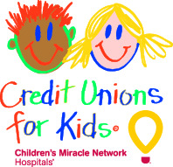

Credit Unions for Kids
Miracle Jeans Day 2018
Team Participation Email #4

SUBJECT: Happy Miracle Jeans Day!
EMAIL TEXT:
Good morning, Credit Union!

Today is not just any old Wednesday. Today is Miracle Jeans Day! The chance to wear jeans to work is great. The chance to be a part of the lifesaving work of Children’s Miracle Network Hospitals is spectacular.

We thank you for your participation and the efforts you made to make this day a successful group effort. What you are doing today will send a message to the children. Don’t forget to tell members why you’re dressed down and remind them that they can donate as well!

Thanks again for supporting the kids and for making miracles happen on this Miracle Jeans Day!
With much appreciation,

Name

*Your local CMN Hospitals’ website likely features patient stories. Link to one here! If you need help finding a patient story, contact your local CMN Hospital representative or MiracleJeansDay@CMNHospitals.org.

