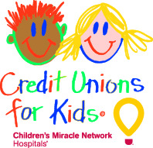

Credit Unions for Kids
Miracle Jeans Day 2018
Team Participation Email #3

SUBJECT: Miracle Jeans Day is Tomorrow!
EMAIL TEXT:
Good morning, Credit Union!
Excitement is building for tomorrow’s Miracle Jeans Day! Tomorrow is the day we can make miracles happen by helping our local Children’s Miracle Network Hospital, and we are inching closer to our goal! So far, we have collected $X which means we are at % of our total goal of $Y! A huge thank you to those who have already made a contribution and for getting members excited about our special cause.
Dressing down tomorrow will be nice but keep in mind that the real miracles happen when we collect more money to help the kids at our local Children’s Miracle Network Hospital, hospital name. Patients like patient name* are counting on you!
You can donate by (Enter instructions based on how you, as team leader, plan to collection donations. Don’t forget to include deadlines!).
Thanks again for supporting the kids!
With much appreciation,
name

*Your local CMN Hospitals’ website likely features patient stories. Link to one here! If you need help finding a patient story, contact your local CMN Hospital representative or MiracleJeansDay@CMNHospitals.org.

