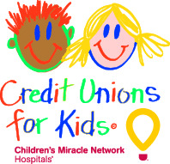

Credit Unions for Kids
Miracle Jeans Day 2018
Team Participation Email #2

SUBJECT: Miracle Jeans Day Reminder
EMAIL TEXT:
Good morning, Credit Union!
We only have a few days left to participate in our local Children’s Miracle Network Hospital’s Miracle Jeans Day! So far, we have collected $X which means we are at % of our total goal of $Y. A huge thank you to those who have already made a contribution.
As a reminder, the funds we raise go to help kids at our local [local CMN Hospital name]. Your contributions help the hospital fund life-saving research, advance technology, support charity care, and provide programs like Child Life Specialists who make the time at the hospital a little easier for the patients, like patient name*.
You can donate by (Enter instructions based on how you, as team leader, plan to collection donations. Don’t forget to include deadlines!).
Thanks again for supporting the kids!
With much appreciation,
name

*Your local CMN Hospitals’ website likely features patient stories. Link to one here! If you need help finding a patient story, contact your local CMN Hospital representative or MiracleJeansDay@CMNHospitals.org.

