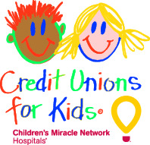

Credit Unions for Kids
Miracle Jeans Day 2018
Sample Newsletter Article #3

Going Casual for the Kids
It’s amazing what dedicated teamwork can do. Credit union employees are “going casual for the kids” and participating in Miracle Jeans Day, a fundraiser benefiting local children’s hospital. On September 12th, members of the credit union staff will donate $5 to the hospital in exchange for wearing jeans to work. Every dollar raised on this day will help us toward our goal of raising $x and contribute to our collective goal of raising $350,000 nationwide.
Members can participate as well! Visit any branch to donate a dollar for a Miracle Jeans Day paper icon. Write your name on the icon, so we can proudly display it in our branch for the weeks leading up to Miracle Jeans Day. When the community comes together out of love and support, we can all see and feel good about the results. It truly is a miracle.
Stop by, and help us support the kids!

